***Section* 1.4 – Volume by Shells**

**Slicing with Cylinders**

***Example***

The region enclosed by the *x*-axis and the parabola  is revolved about the vertical line  to generate a solid. Find the volume of the solid

***Solution***

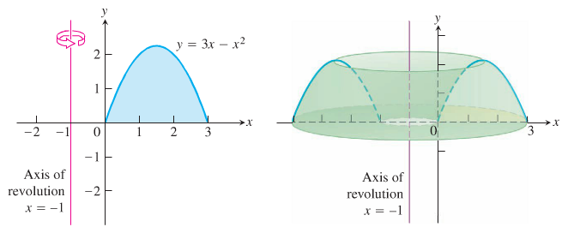

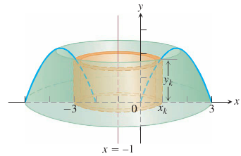

If we rotate a vertical strip of thickness , this rotation produces a cylindrical shell of height  above a point  within the base of the vertical strip.





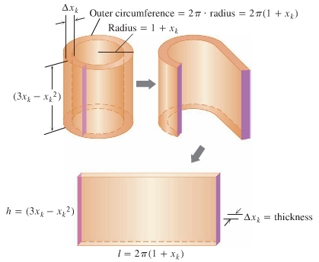

The Riemann sum:



Taking the limit as the thickness  and  gives the volume integral















***Shell Method***

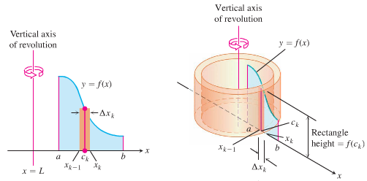



***Example***

Let *R* be the region bounded by the graph of , the *x-*axis, and the vertical line . Find the volume of the solid generated when *R* is revolved about the *y-*axis.

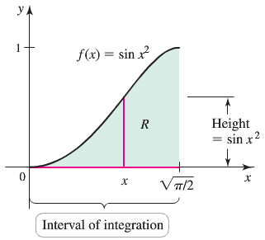***Solution***





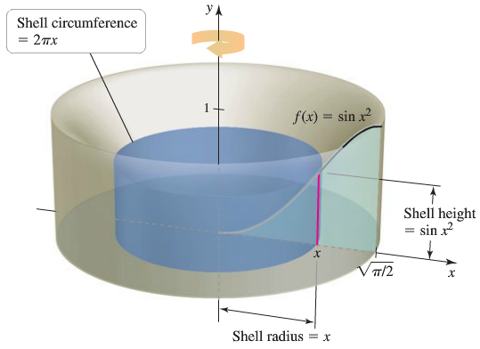 







***Example***

Let *R* be the region in the first region bounded by the graph  and the line .

1. Find the volume of the solid generated when *R* is revolved about the *x-*axis.
2. Find the volume of the solid generated when *R* is revolved about the line .

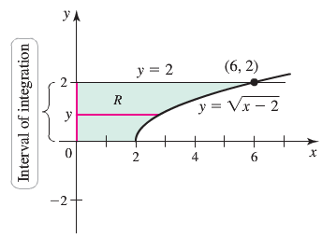***Solution***

1. 







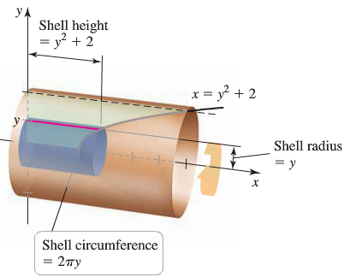 





1. Revolved *R* about the line .



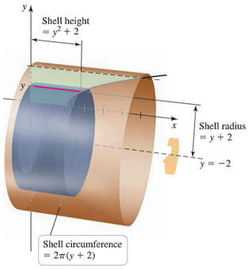 







***Example***

The region *R* is bounded by the graphs of  and  on the interval .

Use the washer method and the shell method to find the volume of the solid formed when *R* is revolved about the *x-*axis.

***Solution***





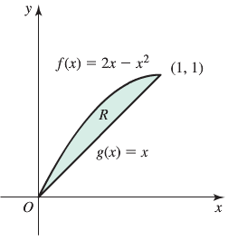

***Washer Method***:











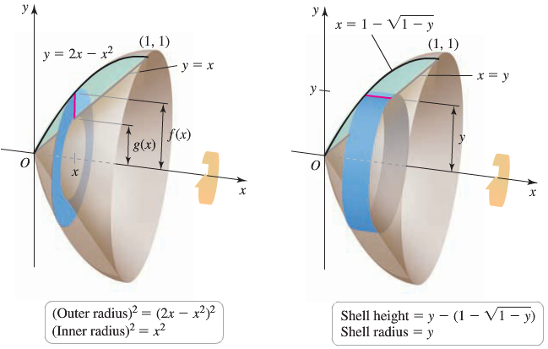

***Shell Method***:

















|  |  |
| --- | --- |
|  |  |

***Summary of the Shell Method***

1. Draw the region and sketch a line segment across it parallel to the axis of revolution. Label the segment’s height or length (*shell height*) and distance from the axis of revolution (*shell radius*)
2. Find the limits of integration for the thickness variable.
3. Integrate the product 2π (*shell radius*) (*shell height*) with respect to the thickness variable (*x* or *y*) to find the volume

|  |  |
| --- | --- |
| ***Integration With respect to x*** | ***Disk/washer method about the x-axis***  Disks/washers are ***perpendicular*** to the *x-*axis |
|  | ***Shell method about the y-axis***  Shells are ***parallel*** to the *y-*axis |
| ***Integration With respect to y*** | ***Disk/washer method about the y-axis***  Disks/washers are ***perpendicular*** to the *y-*axis |
|  | Shells are ***parallel*** to the *x-*axis |

***Exercises*** ***Section* 1.4 – Volume by Shells**

(**1 – 13**) Use the shell method to set up and evaluate the integral that gives the volume of the solid generated by revolving the plane region about the 

|  |  |
| --- | --- |
|  |  |
|  |  |
|  |  |
|  |  |
|  |  |

(**14 – 15**) Use the shell method to find the volume of the solid generated by revolving the shaded region about the indicated axis

|  |  |
| --- | --- |
|  |  |
|  |  |

1. Use the shell method to find the volume of the solid generated by revolving the shaded region about the *y*-axis

|  |  |
| --- | --- |
|  |  |

1. Use the shell method to find the volume of the solid generated by revolving the region bounded by the curve and lines  about the *y*-axis.
2. Use the shell method to find the volume of the solid generated by revolving the region bounded by the curve and lines  about the *y*-axis.
3. Use the shell method to find the volume of the solid generated by revolving the region bounded by the curve and lines  about the *y*-axis.
4. Let 

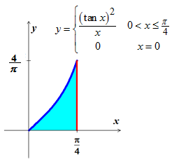

1. Show that 
2. Find the volume of the solid generated by revolving the shaded region about the *y*-axis.
3. Use the shell method to find the volume of the solid generated by revolving the region bounded by the curve and lines  about the *x*-axis.
4. Use the shell method to find the volume of the solid generated by revolving the region bounded by the curve and lines  about the *x*-axis.
5. Compute the volume of the solid generated by revolving the region bounded by the lines  about each coordinate axis using
6. The *shell* method
7. The *washer* method
8. 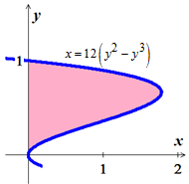Use the shell method to find the volumes of the solids generated by revolving the shaded regions about the *indicated* axes.
9. The *x*-axis
10. The line *y* = 1
11. The line 
12. The line 
13. Use the *washer* method to find the volume of the solid generated by revolving the region bounded by the curve and lines  about

|  |  |
| --- | --- |
| 1. the *x*-axis 2. the *y*-axis | 1. the line *x* = 4 2. the line *y* = 1 |

1. Find the volume of the solid generated by revolving the region bounded by  and the lines  about

|  |  |
| --- | --- |
| 1. the *x*-axis; 2. the *y*-axis; | 1. the line *x* = 2; 2. the line *y* = 4. |

1. The region in the first quadrant that is bounded by the curve , on the left by the line , and below by the line *y* = 1 is revolved about the *y*-axis to generate a solid. Find the volume of the solid by
2. The *shell* method *b)* The *washer* method
3. The region bounded by the curve , the *x*-axis, and the line *x* = 4 to generate a solid. Find the volume of the solid.
4. revolved about the *x*-axis
5. revolved about the *y*-axis
6. Find the volume of the solid generated by revolving the region bounded by  and the lines  about the line *y =* 2.
7. A cylinder hole with radius *r* is drilled symmetrically through the center of a sphere with radius *R*, where . What is the volume of the remaining material?
8. Use the shell method to find the volume of the solid generated by revolving the region bounded by the curve and lines  about the *x*-axis.
9. Find the volume of the region bounded by  revolved about the 
10. Find the volume of the region bounded by  revolved about the 
11. Find the volume of the region bounded by  revolved about the 
12. The profile of a football resembles the ellipse. Find the football’s volume to the nearest *cubic* *inch*.

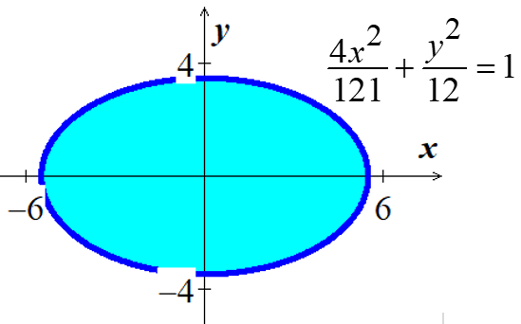

(**36 – 38**) Find the volume using both the *disk/washer* and *shell* methods of

1.  revolved about the 
2.  revolved about the 
3.  revolved about the 

(**39 – 42**) Use the shell method to find the volume of the solid generated by the revolving the plane region about the given line

1. 
2. 
3. 
4. 

(**43 – 44**) Use the disk method or shell method to find the volume of the solid generated vy revolving the region bounded by the graph of the equations about the given lines.

1. 

|  |  |  |
| --- | --- | --- |
|  |  |  |

1. 

|  |  |  |
| --- | --- | --- |
|  |  |  |

1. Let  and  be the volumes of the solids that result when the plane region bounded by , , , and  is revolved about the  and the , respectively. Find the value of *c* for which 
2. The region bounded by , , and  is revolved about the  to form a paraboloid. A hole, centered along the axis of revolution, is drilled through this solid. The hole has a radius *k*, . Find the volume of the resulting ring
3. By integrating with respect to *x*.
4. By integrating with respect to *y*.
5. The region *R* in the first quadrant bounded by the parabola  and the coordinate axes is revolved about the *y-*axis to produce a dome-shaped solid. Find the volume of the solid in the following ways.
6. Apply the disk method and integrate with respect to *y*.
7. Apply the shell method and integrate with respect to *x*.
8. The region bounded by the curves , , and the line  is revolved about the *y-*axis. Find the volume of the resulting solid by
9. Integrating with respect to *x* and
10. Integrating with respect to *y*.
11. The region bounded by the graphs of , , and  in the first quadrant is revolved about the *y-*axis. What is the volume of the resulting solid?
12. The region bounded by  and the *x-*axis over the interval  is revolved about the *y-*axis. What is the volume of the solid that is generated?
13. The region bounded by the graph  and the *x-*axis over the interval  is revolved about the line  . What is the volume of the solid that is generated?
14. The region bounded by the graph  and  is revolved about the line  and the line . Find the volumes of the resulting solids. Which one is greater?
15. The region bounded by the graph ,  and  is revolved about the line  and the line . Find the volumes of the resulting solids. Which one is greater?
16. The region *R* is bounded by the curves 

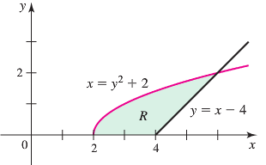

1. Write a single integral that gives the area of *R*.
2. Write a single integral that gives the volume of the solid generated when *R* is revolved about the *x-*axis.
3. Write a single integral that gives the volume of the solid generated when *R* is revolved about the *y-*axis.
4. Suppose *S* is a solid whose base is *R* and whose cross sections perpendicular to *R* and parallel to the *x-*axis are semicircles. Write a single integral that gives the volume of *S*.
5. The region *R* is bounded by  and the *x-*axis on the interval , where  and .

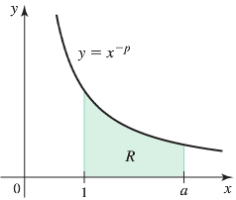

Let  and  be the volumes of the solids generated when R is revolved about the *x-* and *y-*axes, respectively.

1. With  and , which is greater,  or ?
2. With  and , which is greater,  or ?
3. Find a general expression for in terms of *a* and *p*. Note that  is a special case, what is when ?
4. Find a general expression for in terms of *a* and *p*. Note that  is a special case, what is when ?
5. Explain how parts (*c*) and (*d*) demonstrate that 
6. Find any values of *a* and *p* for which 
7. Let *R* be the region bounded by the graph of  and the  on . Find the positive value of *c* such that the volume of the solid generated by revolving *R* about the  equals the volume of the solid generated by revolving *R* about the .
8. Find the volume of the torus (doughnut formed when the circle of radius 2 centered at (3, 0) is revolved about the *y-*axis.
9. Use geometry to evaluate the integral
10. Use Shell method (use integral table)

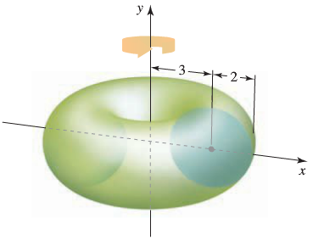

1. The nose of a rocket is a solid of revolution of base radius *r* and height *h* that must join smoothly to the cylindrical body of the rocket. Taking the origin at the tip of the nose and the *x*-axis along the central axis of the rocket, various nose shapes can be obtained by revolving the cubic curve about *x*-axis.



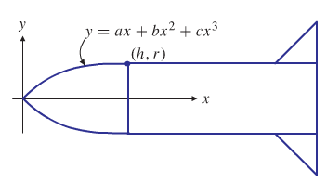

The cubic curve must have slope 0 at *x* = *h*, and its slope must be positive for 0 < *x* < *h*. Find the particular cubic curve that maximizes the volume of the nose. Also show that his choice of the cubic makes the slope at the origin as large as possible and, hence, corresponds to the bluntest nose.

1. A landscaper wants to create on level ground a ring-shaped pool having an outside radius of 10 *m* and a maximum depth of 1 *m* surrounding a hill that will be built up using all the earth excavated from the pool. She decided to use a fourth-degree polynomial to determine the cross-sectional shape of the hill and pool bottom: at distance ***r*** *m* from the center of the development the height above or below normal ground level will be



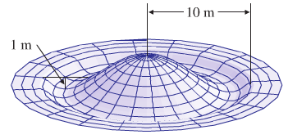

For some *a* > 0, where *k* is the inner radius of the pool.

Find *k* and *a* so that the requirements given above are all satisfied.

How much earth must be moved from the pool to build the hill?